All About Me!
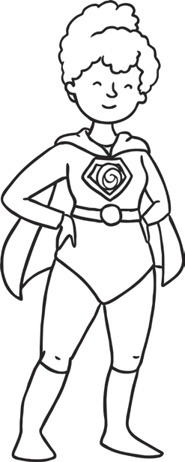
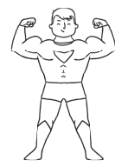
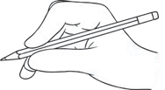
Name: Age: Birthday: I would like to be a when I grow up.
My teacher is: Write your superhero name here!
My favourite things.
Food: TV show: Film: Book: Sport: Holiday: Animal: Place:
This is me!

My family!
Interesting fact about me:

Things I like to do:

