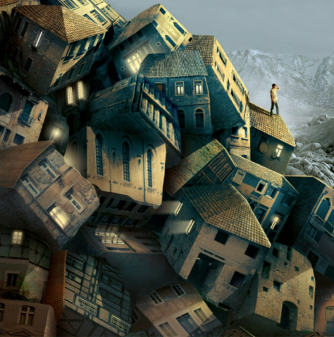
Story Starter!
He had only been away for a short time.
Upon returning to his home-town, Jake found that it was no longer there: something terrible had happened. After eventually locating his house (it had moved several hundred miles from its previous location) Jake stood on top of it and surveyed the calamitous scene around him. What could have caused such a thing to happen?

Can you continue the story? You could write a flashback, describing what happened to the town, or write about how Jake tries to solve the mystery.
.
Question Time!
What do you think caused this event to happen?
None of the houses appear broken or damaged. What does this suggest to you?
Are there still people inside the houses?
If you were Jake, how would you manage to save them?
How is it that the lights are still on?

Perfect picture!
Think about what might have caused the houses to be piled up like this. Draw/describe how it happened.
English Day 2

